LIMEHOUSE PROJECT

RAISING ASPIRATIONS I CHANGING LIVES
St Anne Unit 2, 789-791 Commercial Road
London. E14 7HG
Tel: 0207 531 4881

Front-Line Generalist Adviser

Recruitment Pack
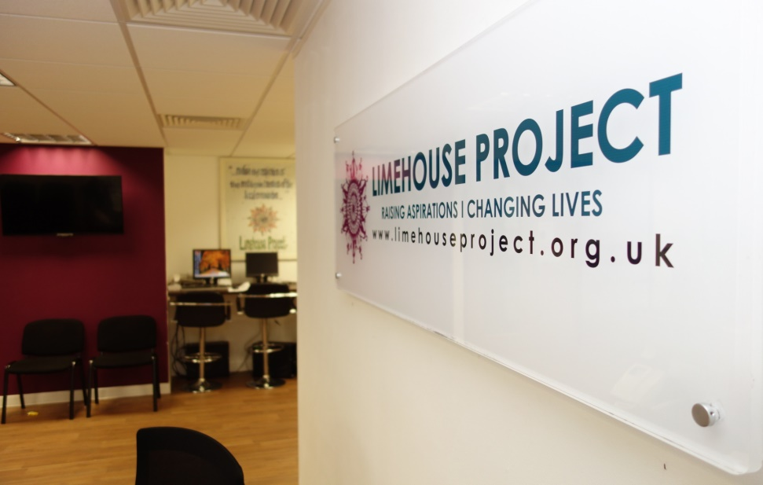

November 2023

Dear Applicant,

Thank you for taking the time to consider the role of Front-Line Generalist Adviser with the Limehouse Project.

The Limehouse Project (LHP) is a thriving grassroots and award-winning organisation with a history of servicing the Limehouse area of Tower Hamlets and East London since 1984. We provide free welfare and debt advice, accredited learning, capacity-building, employment support programmes, health and wellbeing activities and childcare provision. We work independently of and in partnership with key third-sector businesses and statutory organisations to ensure each client is given the timely and active support they need to positively move forward in life.
We are looking to appoint an experienced Front-Line Generalist Adviser with excellent written and verbal communication skills with an ability to develop and maintain effective working relationships with people from diverse communities and backgrounds. If you want to join a friendly, compassionate and hugely dedicated team, Limehouse Project is the place.

We are looking for someone who will commit to the aims and values of LHP and the provision of high-quality advice and support services for our clients.
You will need to be compassionate, empathetic, and sensitive with excellent listening skills to capture the needs and issues of the clients.
- You must have great people skills
- Ability to handle difficult telephone conversations
- Good communication and written skills
- Confident and able to react quickly
- Well organised, a process-driven individual who can work independently as well as part of a team

Enclosed are as follows:
- Job Description & Person Specification.
- Application form.
- Guidance notes on completing the application form.
- Limehouse Project recruitment monitoring form.

For the application pack please email recruitment@limehouseproject.org.uk.

If you would like an informal chat about the role, please contact Farida Yesmin (C.E.O.) on 07985 446778 or by email at f.yesmin@limehouse project.org.uk.

Thank you again for your interest in this role and we look forward to receiving your completed application.

Please email the completed application form and recruitment monitoring form along with a cover letter to Limehouse Project to recruitment@limehouseproject.org.uk.

Closing date: 4th December 2023
Yours sincerely,

Mrs. Farida Yesmin
C.E.O.

Job Advert & JD

Job Title: Front-Line Generalist Adviser
Accountable To: The Director
Responsible To: Advice Services Manager
Hours: 21 hours per week
Annual Salary: £13,049
Location: Limehouse Project (On-Site)

PURPOSE OF THE JOB:

We are seeking an empathetic and resourceful Front-line Generalist Adviser to provide generalist advice and support to individuals seeking assistance in various areas at the front line. This role involves being the first point of contact, and your primary responsibility is to provide empathetic and accurate information across a broad range of issues, such as welfare benefits, housing, money & debt etc. Carry out effective triaging, ensuring individuals receive accurate and timely advice and can access the appropriate support and services according to their needs.

The Front-Line Generalist Adviser will be responsible for administering the front-line services, including advice telephone line, incoming referrals, reception drop-ins and supporting the admin volunteers.

KEY DUTIES AND RESPONSIBILITIES:

- To actively engage in a front-facing capacity, delivering first-class administrative support to maintain the seamless operation of the LHP Advice Services. This involves ensuring that reception and general office duties are conducted in a manner that reflects a friendly, well-organised, and highly efficient environment.
- To maintain and improve advice service operations by ensuring all calls are answered within agreed time scales and in the appropriate manner.
- To listen actively and empathetically to understand the client's concerns and needs.
- To ensure clients are aware of relevant deadlines, application processes, and required documentation.
- To screen and acknowledge all incoming advice referrals via all portals and update the LHP database with actions and outcomes.
- To ensure that the service offered is tailored to the needs of clients and takes into account the particular needs of each individual, including issues around communication, understanding and vulnerability.
- To carry out effective friendly communication with service users, provide initial advice and ensure carrying out effective triage while answering calls.
- To provide high-quality initial generalist advice and support on social welfare issues to our clients that conform to the Advice Quality Standard (AQS).
- Complete necessary forms and documentation to initiate or support welfare applications on behalf of our clients.
- Provide initial advice and assistance through a range of channels; face-to-face, telephone, teams/zoom, WhatsApp as well as via email/letter.
- To open the advice service appointment sheet and monitor the level of take-up of the service maintain the effective use of the advice appointment sheet.
- To open a monthly Advice Service waiting list and place our clients on the waiting list once the appointments are fully booked
- To ensure that all necessary and appropriate records are being maintained using the LHP Share-Point and LHP Lamplight Database.
- To ensure that all necessary monitoring is properly carried out. In particular to ensure that the LHP database is updated with all client registration including personal data and GDPR Consent and Communications in a correct and timely manner.
- To provide weekly reports on recording and monitoring to the Advice Services Manager.
- Maintain open and honest channels of communication at all levels across the organisation to facilitate and share best practices.
- Comply with AQS case recording procedures and processes, contributing to the delivery of high-quality advice, and the collection and reporting of statistical data as required to enable accurate evaluation of the impact of the service and reporting to funders.
- Keep up to date on social welfare issues and good practices including attending training courses and using online resources.
- To remain alert to issues relating to capacity, client understanding and safeguarding issues when working with clients and promptly consult with the Advice Services Manager regarding any areas of concern.
- To be responsible for the delivery of an agreed annual advice work plan, meeting targets and milestones.
- To contribute to the monitoring of the project and provide quarterly and annual monitoring data and evaluative reporting to the Project Manager for dissemination to the funders.
- To liaise with other agencies as necessary in the interests of clients and the provision of effective service, and to develop and sustain good working relationships with those agencies.
- To actively contribute to the delivery of various other advice projects, and actively refer clients to the LHP services and external partner services.
- To follow the key date task diary on the LHP database system.
- Supported by the Services Manager and members of the team, you will collectively develop relationships with other organisations attending various borough-wide forums.
- To strictly adhere to all LHP policies, in particular those on confidentiality, equal opportunity, case recording, file management policy etc. Strictly follow the AQS Quality System e.g. clients’ filing system, monitoring system, referral system etc, and keep them up-to-date.
- Follow the Agreement that Limehouse Project has with that Centre and share good practices with its workers.
- To establish and maintain warm relations of trust and cooperation with clients in keeping with the Limehouse Project ethos.
- To observe all rules relating to Health and Safety.

Supporting Volunteers:

- Provide support to admin volunteers and offer training and support to ensure all volunteers have a clear idea about their admin roles.
- Support volunteers on their tasks.
- To allocate equipment and other resources to each volunteer and keep appropriate records.
- To have monthly 1:1s meetings with volunteers and empower them to fulfil their roles.
- To ensure that the LHP database is recorded effectively by you and volunteers.

ALL MEMBERS OF STAFF ARE EXPECTED TO:

- To support the Limehouse Project’s overall goals and vision.
- Carry out day-to-day general administrative duties that are vital to the smooth running of advice work such as responding to letters, doing follow-up work etc, and its online appointment sheets for LHP and external partners.
- Provide regular reports to the Limehouse Project Services Manager.
- Carry out other duties, requested by the LHP managers and management committee from time to time.
- Take care of your health and safety at work and that of other employees and co-operate with Limehouse Project in complying with statutory duties.
- Take an active part in regular 1:1 meetings and team meetings and be involved in the development of the LHP services.
- Work with volunteers as applicable.
- Participate in staff development and training programmes including formal supervision and appraisals.
- Any other duties required, which may be deemed to fall within the scope of the post

GENERAL DUTIES:

- Open mail/emails in the morning, and take necessary action.
- Answer the telephone, listen to answerphone messages, and take action.
- Carry out day-to-day general administrative duties that are vital to the smooth running of advice work, such as responding to letters, doing follow-up work etc.
- Carry out such other duties, as the LHP manager and management committee shall from time to time require.
- Keep up to date by undertaking such further study or training, as may be necessary or which may be required by LHP and which contributes to the provision of an effective service.

FRONT LINE GENERALIST ADVISER - PERSON SPECIFICATION

REQUIREMENTS | Essential | Desirable
Education/Training:
Training or Vocation (NVQ, DIP) qualification in Advice and Guidance.  Educated to degree level. | X | X
Knowledge, Understanding, Experience and awareness of:
Minimum 1 year experience in a similar post. | X
Experience in advice work - providing one-to-one Information, Advice, Support or Guidance sessions. | X
An understanding of financial literacy. | X
Working within a diverse community. | X
Working knowledge and understanding of the needs of disadvantaged local residents, especially BAME communities and the challenges they face in LBTH | X
Working to clear goals and targets. | X
Recording communications, outcomes and report writing. | X
Knowledge of how the voluntary sector operates in providing service & how the voluntary sector may be funded |  | X
Knowledge of quality mark standards such as AQS, Community Legal Service Quality Mark standard, and Investing in Volunteers. | X
Good knowledge of computer systems - Microsoft Office, Apps, Google Docs, CRM (e.g. AIM’s, Advice Pro, Lamplight, Key2CRM software etc.). | X
Issues faced by disadvantaged communities and residents in Tower Hamlets |  | X
Experience in monitoring and evaluation. | X
A good knowledge and aptitude for engaging and motivating partners, agencies, sub-contractor organisations and staff at all levels | X
Experience in working with other partners and agencies in developing and implementing joint programmes. |  | X
Experience working as a team player - being responsive, defining a common purpose, sharing information and working under pressure towards targets. | X
Skills and Abilities:
Excellent written and verbal communication skills for a range of audiences. | X
Excellent oral and written communication skills in English | X
Ability to communicate in other languages such as Bengali/ Sylheti. |  | X
Skills as a creative and effective problem solver. | X
Ability to effectively share learning, contribute to and influence the development of good practice. | X
Excellent organisational skills, attention to detail, ability to manage multiple workstreams, tasks and working to tight deadlines | X
Ability to provide and present professional reports. | X
Committed to delivering a high-quality service at the front line. | X
Good working knowledge of Microsoft Office and database programmes. | X
Highly motivated and enthusiastic approach to work. | X
Commitment to the benefits of volunteering and supporting volunteers. | X
Ability to work without supervision. | X
Ability to work under pressure, both on your own and as part of a team. | X
Ability to effectively share learning, and contribute to and influence the development of good practice. | X
Ability to provide advice and guidance in a culturally sensitive manner | X
Excellent organisational skills, (including attention to detail), managing multiple workstreams, and tasks and working to tight deadlines. | X
Circumstances
You will be required occasionally to attend meetings, conferences etc. outside of normal office hours and at weekends |  | X
Equal Opportunities
Demonstrate in your application and interview an understanding and ability to reflect equality issues in all areas of work and to promote its importance to all service users. | X

Limehouse Project is an equal opportunities employer that values the importance of diversity and positively welcomes applications from all members of the community, including those with disabilities. Please note that successful applicants to this post will be subject to a Disclosure and Barring Service Check (DBS). Confirmation of appointment would be dependent on a satisfactory DBS check.

Limehouse Project
St Annes Unit 2,
789-791 St Anne Street
Commercial Road
London E14 7HG

Registered Charity: No.295857 and Company Limited by Guarantee No.1817676

