LIMEHOUSE PROJECT

RAISING ASPIRATIONS I CHANGING LIVES
St Anne Unit 2, 789-791 Commercial Road
London. E14 7HG
Tel: 0207 531 4881

Money & Debt Caseworker
Recruitment Pack
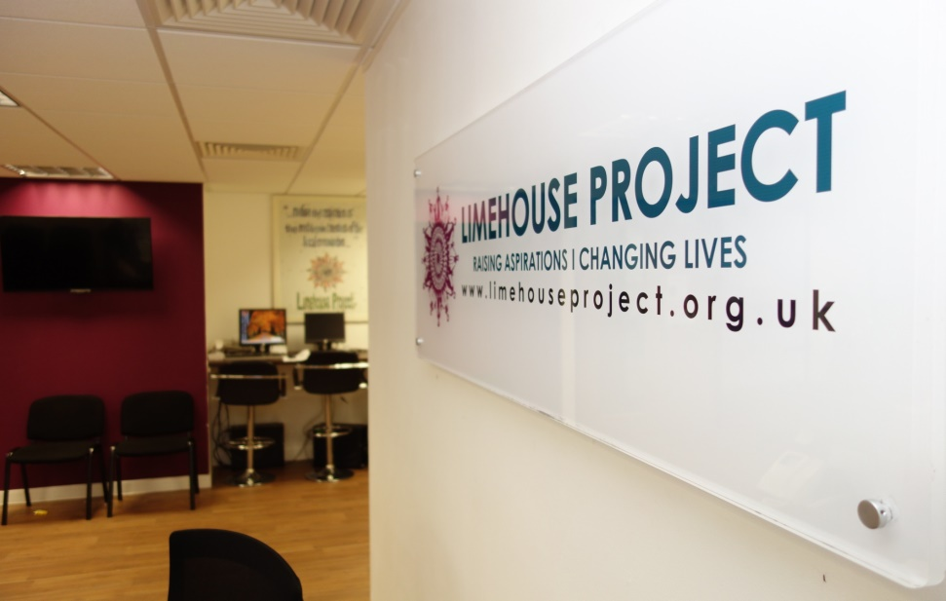

December 2021

Dear Applicant,

Thank you for taking the time to consider the role of the Money & Debt Caseworker position at Limehouse Project.

The Limehouse Project (LHP) is a thriving grassroots and award-winning organisation with a history of servicing the Limehouse area of Tower Hamlets and East London since 1984. We provide free confidential welfare and debt advice, accredited learning, capacity-building, employment support programmes, health and wellbeing activities and childcare provision.
We work independently and in partnership with the key third sector, business and statutory organisations to ensure each client is given the timely and active support they need to positively move forward in life.
We are looking to appoint an experienced Money & Debt Caseworker with excellent skills at the casework level who will provide high-quality debt and money advice to our clients. We are looking for someone who will commit to the aims and values of LHP and the provision of high-quality advice and support services for our clients to empower them towards financial independence.

Enclosed are as follows:
1. Job Description & Person Specification
2. Application Form
3. Guidance Notes on completing the Application Form
4. Limehouse Project Recruitment Monitoring Form

If you would like an informal chat about the role, contact Tahmina Rahman (Advice Services Manager) on 0207 538 0075 or by email at t.rahman@limehouseproject.org.uk.

Please send the completed application form along with a covering letter to Farida Yesmin (CEO) of the Limehouse Project at recruitment@limehouseproject.org.uk.

Closing date: Monday 10th January 2022 at 9:00 am
Thank you again for your interest in this role and we look forward to receiving your completed application.

Yours sincerely,

Mrs Farida Yesmin
CEO

Job Advert - Money & Debt Caseworker

Position: Money & Debt Caseworker
Hours: Full time
Contract: Fixed Term Contract till 31st March 2023
Salary: £33,000 per annum Including London Weighting

Who are we: The Limehouse Project (LHP) is a thriving grassroots and award-winning organisation with a history of servicing the Limehouse area of Tower Hamlets and East London since 1984. We provide free welfare and debt advice, accredited learning, capacity-building, employment support programmes, health and wellbeing activities and childcare provision.
We work independently and in partnership with the key third sector, business and statutory organisations to ensure each client is given the timely and active support they need to positively move forward in life.
Context: We are looking to appoint an experienced Money and Debt Caseworker with excellent skills at the casework level who will provide high-quality debt and money advice to our clients. We are looking for someone who will commit to the aims and values of LHP and the provision of high-quality advice and support services for our clients to empower them towards financial independence.

You will be joining our Advice Team consisting of a full-time debt advisor and eight welfare benefit advisors who provide welfare benefits, housing, debt, immigration and energy advice and casework across a range of projects. In addition to specialist level advice and casework, Limehouse Project also provides money management and budgeting support service to clients who cannot manage their finances without support.
Purpose Of the Role: To provide a specialist level of Money and Debt advice/casework support also provide advice on welfare benefits issues to maximise the client's income. Provide practical assistance and support around money management; budgeting; saving; debt and understanding and accessing appropriate financial products. You will preferably have a qualification in money advice or be prepared to work towards obtaining this. You must have excellent communication and digital skills, deliver telephone and face-to-face advice and support, also be able to plan and organise your work.
You will be based at our main office and also be working from home on a flexible or regular basis. All staff are currently working on a flexible working arrangement and work partly from office and home due to the Covid-19 Pandemic.
Please send the completed application form along with a covering letter to Farida Yesmin, C.E.O. of the Limehouse Project at recruitment@limehouseproject.org.uk

Closing date: Monday 10th January 2022 at 9:00 am

Thank you again for your interest in this role and we look forward to receiving your completed application.

Job Description- Money and Debt Caseworker

Job Title: Money & Debt Advice Caseworker
Accountable To: The Director
Responsible To: Advice Services Manager/Casework Supervisor

PURPOSE OF THE JOB: To provide one-to-one specialist advice and casework level support on Money and Debt management to residents in the Tower Hamlets, which includes practical assistance and support around money management, budgeting, saving, debt and understanding of accessing appropriate financial products, also to provide advice on welfare benefits issues to maximise client's income. To keep personal technical and legislative knowledge up-to-date and to provide technical support to advisers and caseworkers.

ROLE DESCRIPTION:

Job title: Money and Debt Caseworker
Hours: 35 hours per week
Salary: £33,000 per annum (pro-rata on FTE)
Reports to: Advice Services Manager/Casework Supervisor
Location: Limehouse Project, Unit2, 789 Commercial Road, London E14 and Other outreach venues across the borough

Money and Debt Caseworker - KEY DUTIES and RESPONSIBILITIES:
- To provide a specialist debt advice and casework service that conforms to the Advice Quality Standard (AQS).

- To support clients to resolve their debt, benefit and money management issues, and act and negotiate on clients’ behalf with third parties as appropriate.

- To advise and assist with applications to increase income from other sources, including local authority discretionary housing payment schemes, utility companies and charitable trusts etc.

- Provide advice and assistance through a range of channels; Face-To-Face, Telephone, Teams/Zoom, WhatsApp as well via email/letter.

- To ensure that the service offered is tailored to the needs of clients and takes into account the particular needs of each individual, including issues around communication, understanding and vulnerability.

- Through clear communication and consultation, ensure that clients remain involved in resolving their debt, benefit and money management issues and are kept informed on the progress of their case throughout our work with them.

- To provide one-to-one support and deliver group workshops around; money management; income maximisation; budgeting; saving; debt and understanding and accessing appropriate financial products.

- Comply with AQS case management and case recording procedures and processes, contributing to the delivery of high-quality advice and casework, and the collection and reporting of statistical data as required to enable accurate evaluation of the impact of the service and reporting to funders.

- Keep up to date with legislation, case law, and good practice in debt and welfare benefits advice including attending training courses and using online resources.

- To remain alert to issues relating to capacity, client understanding and safeguarding issues when working with clients and promptly consult with the Advice Services Manager/Casework Supervisor regarding any areas of concern.

- Adhere to the policies and procedures of Limehouse Project and take an active role in reviewing and improving the services offered.

- To conduct cases at all stages from review to appeal procedures, to preparing evidence for submission and specialist support.

- To be responsible for the delivery of an agreed annual advice work plan, meeting targets and milestones.

- To liaise with other agencies as necessary in the interests of clients and the provision of effective service, and to develop and sustain good working relationships with those agencies.

- To actively contribute to the delivery of various other advice projects, and actively refer clients to the LHP’s employment team for employment and careers support.

- To carry out monthly clients’ file reviews and take action and follow key date task diary on the LHP database system.

- To contribute to the overall management of the advice service, working collaboratively with colleagues to ensure that the project delivery plan and annual work plan(s), are delivered to meet agreed targets within an agreed timescale.

- Supported by the Services Manager and members of the team, you will collectively develop relationships with other organisations attending various borough-wide forums.

- To contribute to the monitoring of the project and provide quarterly and annual monitoring data and evaluative reporting to the Project Manager for dissemination to the funders.

- To strictly adhere to all LHP policies, in particular those on confidentiality, equal opportunity, case recording, file management policy etc. Strictly follow the AQS Quality System e.g. clients filing system, monitoring system, referral system etc, and keep them up-to-date.

Supervising debt advice sessions and casework:

- To provide an appropriate level of support and supervision to debt advisers and other welfare benefits advisers on debt issues.

- To monitor advisors debt case recording of advice to meet advice quality standards and service level agreements.

- To ensure remedial and developmental issues are identified and acted upon to develop individuals, improve the quality of advice, and ensure clients do not suffer detriment due to poor or inadequate debt advice service provision.

- To keep personal technical and legislative knowledge up-to-date and to provide technical support to advisers and caseworkers.

- To provide one-to-one and group training sessions on debt and money advice to build and support an integrated, high performing and successful team of advisers and caseworkers.

All members of staff are expected to:
- To support the Limehouse Project’s overall goals and vision.
- Carry out day-to-day general administrative duties that are vital to the smooth running of advice work such as responding to letters, doing follow up work etc, and its online appointment sheets for LHP and external partners.
- Provide regular reports to Limehouse Project Services Manager.
- Carry out other duties, requested by the LHP managers and management committee from time to time.
- Take care of your health and safety at work and that of other employees and co-operate with Limehouse Project in complying with statutory duties.
- Take an active part in regular team meetings and be involved in the development of the LHP services.
- Work with volunteers as applicable.
- Participate in staff development and training programmes including formal supervision and appraisals.
- Any other duties required, which may be deemed to fall within the scope of the post

Person Specification – Money and Debt Caseworker
Experience
In debt advice and casework with a minimum of 1-year recent experience (full-time or equivalent). | Essential
Recent experience in giving welfare benefits advice | Essential
Experience in providing advice and/or casework over the telephone | Desirable
Experience in working with housing association tenants | Desirable
Communicating effectively with a range of individuals and organisations in person, by phone and by mail | Essential
Qualifications
Be an approved Debt Relief Order Intermediary and hold the Institute of Money Advisers Certificate in Money Advice Practice, or equivalent, or have a willingness to work towards these qualifications, including some study in your own time. | Desirable
Skills and Abilities
Ability to listen, analyse information and identify issues and explain complex information in a clear effective way | Essential
Excellent telephone and oral communication skills | Essential
Proficient and confident in the use of IT | Essential
Ability to record information using clear language | Essential
Work on a self-supervision basis, prioritise own work and meet deadlines | Essential
Contribute effectively to the team and to the efficient running of the office  An ability to use initiative, patience and perseverance to help resolve problems | Essential
An ability to maintain personal boundaries | Essential
An ability to remain calm under pressure and to set priorities to handle workload effectively | Essential
Commitment
To work effectively with other voluntary and statutory agencies to address the needs of clients | Essential
To undertake training as appropriate to the role | Essential
To maintain the aims of the service specifically relating to confidentiality and Equal Opportunities | Essential

Limehouse Project is an equal opportunities employer that values the importance of diversity and positively welcomes applications from all members of the community, including those with disabilities. Please note that successful applicants to this post will be subject to a Disclosure and Barring Service Check (DBS). Confirmation of appointment would be dependant on a satisfactory DBS check.
Limehouse Project
St Annes Unit 2
789 - 791 St Anne Street
Commercial Road
London E14 7HG

Registered Charity: No. 295857 and Company Limited by Guarantee No. 1817676

