Company Number: 1817676
Charity Number: 295857

Annual Report & Financial Statements
For Year Ending 31st March 2020

Contents
Chair’s Foreword 3
Governance and Objectives 4

LHP Services
Goal 1: Increasing Access Improving Knowledge 9
Goal 2: Developing Skills, Mobilising Communities 11
Goal 3: Supporting Healthier Integrated Communities 14
Goal 4: Volunteering 15
Goal 5: Childcare Provision 17

Annual Accounts (Page No)

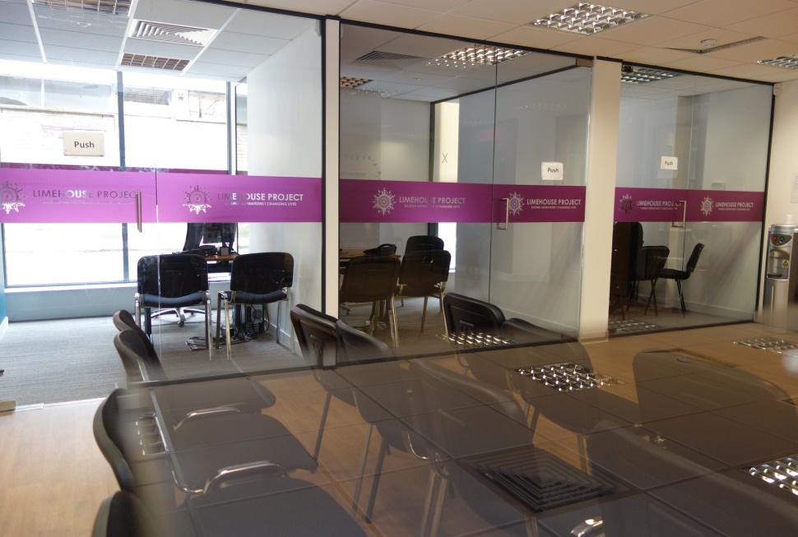
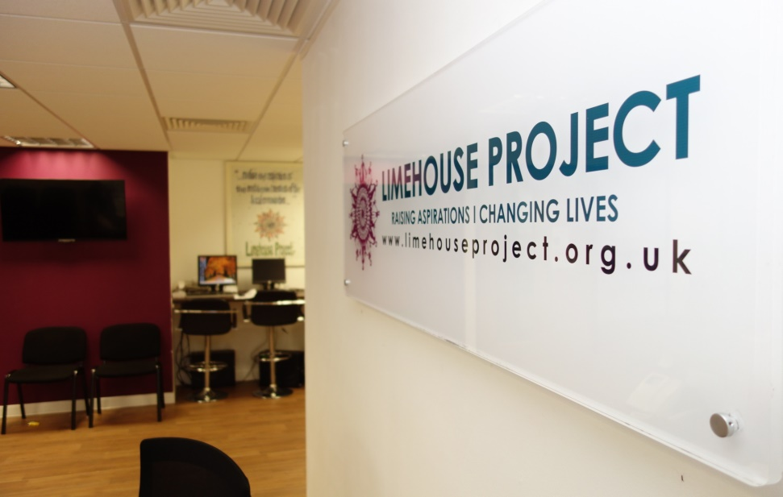

Message From Our Chair
Thanks to the support of an inspired team of dedicated Trustees, staff and volunteers, the Limehouse Project continues to develop innovative services to meet the changing needs of disadvantaged local residents.

While sustaining relevant, inclusive and accessible means of helping each individual coming through our door in addressing any barriers of confidence, finance, language, digital skills and training to making the most of their existing skills, by improving the quality of life of service-users, we also build foundations upon which a wider local community can thrive.

While sadly, programmes such as our Fit for Life initiative supporting 30 isolated older residents to come together for collective gentle exercise to improve health and extend social networks has come to an end, fresh opportunities such as our Living Well Club which provides healthy meals twice-weekly, digital drop-in sessions and workshops helping particularly vulnerable older people access programmes such as WhatsApp to keep connections with family and friends have grown to support 30-40 participants weekly.

A dedicated Volunteer Coordinator has also updated and improved protocols and support mechanisms for our talented team of volunteers who’s profiles range from university students to socially-isolated women engaging in civic activities for the first time. While one might support our Living Well Club sessions, another might update our social media marketing strategies and practical capacity.

Special thanks go to all, be it out IT student who designed and delivered IT support sessions for first time digital clients, or to classroom assistants helping our training team deliver efficient and effective outreach workshops. Our application for nationally-recognised Investing in Volunteers accreditation has now been submitted to underpin the good work of our team and ensure quality experiences for each and every volunteer joining our team!

Building on the success of our Little Limehouse Pre-school which addresses a shortage of affordable and quality childcare locally while providing work experience opportunities for trainees on our accredited childcare course seeking qualifications for their first ever employment, we now wish to develop further income generating activities providing quality social benefits while enhancing our financial independence and resilience in turbulent times.

As we enter a period of financial stability, thanks are due for hard-work and leadership from our Director, Farida Yesmin, Fundraising Officer, Gerard McKinney (who also helped reinvigorate our financial management systems this year), and Kay Browne who straddled multiple roles managing our Advice Team and - when we said a warm goodbye to Juliana Ajibade, our formidable Access to Employment Manager of six years’ standing - our training for employment team as well. Thanks to the generosity, dedication and determination of all of you, our service, more relevant than ever in times of crisis, is positioned to swiftly adapt and service vulnerable people mainstream services are often not able to reach.

Dennis Twomey, Chair
Governance and Objectives
Our Trustees
Dennis Twomey Chair and Acting Treasurer
Atiya Sheikh Committee Member
Alisha Azmin Committee Member
Adina Goga Committee Member
James Invine Committee Member
Shepu Miah Committee Member
Jacqueline Baillie-Nelson Committee Member

Our Senior Management Team

Farida Yesmin CEO
Kay Browne Access to Employment Services Coordinator
Memuna Iyasere Advice Services Coordinator

Our Auditors

Harmer Slater,
Salatin House,
19, Cedar Road, Sutton
Surrey, SM2 5DA

Our Bankers

NatWest Bank
Dockland South Quay Branch
54, Marsh Wall, London E14 6LJ

Our Solicitors

Russell Cooke

Our Governing Document

The Limehouse Project (LHP) is a registered charity since 7th January 1987 and has been incorporated as a Company Limited by Guarantee since18th May 1984. Our Articles of Association details our aims and objectives, management accountability and mechanisms through which Trustees are elected.

Aims & Objectives

LHP seeks to identify, highlight and meet the needs of the inhabitants of Tower Hamlets and East London regardless of gender, gender orientation, race, religion, political affiliation or opinions held of aforementioned inhabitants.

We work independently and in partnership with organisations including local authorities, Residential Social Landlords, voluntary and community organisations in order to advance education, relieve poverty and welfare needs, advance good health and provide facilities as required for the promotion of social welfare, recreation, leisure and community development which improve the quality of life for local residents.

A Legacy of Listening

We are proud of our heritage as a charity emerging from a grass-roots local campaign to address homelessness and a rise in racial attacks.
The LHP delivers a diversity of services for local people whose feedback and insights help identify emerging and unmet need in light of evolving demographic and social trends.
This, in turn, informs future strategies to identify further gaps in local services to meet the needs of some of Britain’s most disenfranchised residents through innovative, accessible and sustainable services.
While extending our geographic reach into further areas of unmet need in East London, we have built the capacity of staff members largely drawn from amongst local BAME residents who speak local community languages and become positive role models for local residents who are furthest from employment markets.
Our work responds to local issues as they arise. While developing new projects such as those highlighted further in this report to ensure our services remain relevant and effective, we deliver a range of services responding to the changing needs of local people.
Achievements such as our nationally-acclaimed award as the Best Women in Housing award for 2018 speak of our bonds of trust with some of Britain’s hardest-to-reach residents and professionalism in helping them achieve.

Management Structure

We are governed by a voluntary and elected body, composed of local people with a wealth of professional expertise which includes former teachers, employment advisers, risk and management consultants, local business and financial sector representatives, Our Trustees meet quarterly to consider strategies and provide guidance on questions of finance, sustainability, human resources and service delivery.

Induction of New Trustees

LHP and potential trustees often come to each other’s attention through our extensive networks. Upon joining, each new trustee is issued with an induction pack and invited to attend short training sessions to familiarise themselves with the context in which we work and our constitutional framework. Annual Planning Days also offer incoming trustees an opportunity to discuss our strategic priorities.

Principal Funding Sources

LHP’s work is supported through statutory and private charitable trust grants and Service Level Agreements (SLAs). Current funders and partnerships include:

- London Borough of Tower Hamlets funded LCF Partnership Consortium: delivering social welfare advice and skills development training programme.
- National Lottery Community Fund: for skill development training of local women.
- GP Health Advice Initiative: networking advice and health agencies.
- Crucial funding and other support are also provided by City Bridge Trust, The Lloyds Bank Foundation, Ocean Regeneration Trust, East End Community Foundation, Paddington Development Trust, Power to Change, The Home Office, Big Energy and many more funders supported our delivery of services and ensuring our future financial sustainability.

Financial Review

The LHP has been fortunate in being able to develop and sustain new income-generation assets which meet our aims of building local capacity while ensuring our longer-term sustainability.

Our pre-school, launched in 2017, continues to generate income while providing a quality childcare service for local parents. LHP also continues to expand our partnerships with voluntary sector and statutory bodies to deliver key services.

Reserves Policy

We, the trustees of the Limehouse Project, believe that a strong reserves policy supports the sound financial management of our charity. Most of the charity’s funding comes from commissions and grants awarded by statutory bodies (approx. 70% annually), grants from trusts and foundations (approx. 20% annually), and earned income through our preschool provision along with a small amount of letting income (approx. 10% annually).

We seek to maintain a level of unrestricted reserves in order to protect the Limehouse Project from major risks (such as an unforeseeable loss of income), maintain financial resilience and ensure the charity’s long-term future.

We recognise that our reserves policy should be flexible, risk focused and actively monitored and reviewed during each financial year as part of our internal financial management. To that end, our regular management accounts reporting includes an estimated reserves analysis with explanations of any variances from our current reserves policy.

Our total unrestricted reserves policy for this financial year is £943,000, consisting of £643,000 in designated reserves and £300,000 in free reserves.

Of our designated reserves allocations:
- We have an allocation of £423,000 which relates to land and buildings which we need in the short and medium term to deliver our services and are therefore not available as liquid assets.
- We hold an allocation of between three and six months for staff and administrative overheads for back office core costs. We currently hold £90,000 which represents six months.
- As a prudent precaution, we have set aside an allocation of £50,000 for potential redundancy costs in the event of the organisation having to close due to adverse financial conditions.
- We are pursuing opportunities to develop our premises to accommodate an expansion in our service provision. This will require an amount of initial capital expenditure, and an allocation of £80,000 has been set aside as a contribution towards these endeavours.

The charity’s current free reserves level is set at £300,000 in order to support up to six months direct frontline service provision which may be affected by unanticipated threats and eventualities. Our 2019/20 free reserves levels of £178,773 represents approximately four months funding for these critical frontline services.

As this financial year ended, we saw the onset of the Covid-19 pandemic and the resultant lockdown across the country. While the crisis may adversely affect our cash flow and funding in the short-term, we hope that the financial resilience of our reserves policy will help the Limehouse Project emerge out of the pandemic a much stronger organisation which will continue to provide flexible, vital services for our marginalised citizens in our local communities.

Risk Management

Procedures are in place to ensure compliance with health and safety requirements for clients, staff, volunteers and visitors to our premises and LHP Trustees have established an annually-reviewed risk register alongside mitigating procedures.

Internal financial control risks and risks to funding are managed through strategic planning ensuring transparency and diversity in funding sources.

Assuring Quality Services

LHP ensures staff regularly supervision and training to ensure a good standard of services. Members of our advice team are bilingual in community languages, have a good understanding of clients’ needs and have on average six years’ experience of listening, advising and undertaking casework.

Our services are routinely inspected by external agencies to ensure our work meets established quality assurance requirements; we hold nationally-recognised Advice Quality Standards for our advice services, Level 1 Office of Immigration Services Commissioner (OISC) certification for casework.

We are also a registered licence holder (LHP FCA 618791) with the Financial Conduct Authority for our delivery of Debt and Money Advice and we have held the Matrix quality assurance certification since 2005.

Planning for the Future

LHP undertakes regular strategic reviews to help consolidate and enhance our capacity to work flexibly and effectively in a rapidly changing charitable service sector.

Our development aims, as identified in our current three-year Business Plan, further address strategies including:

- Strengthening the LHP as a community hub by increasing the capacity of existing services;
- Exploring demand for further provision and partnerships to meet needs identified by existing and new potential service beneficiaries to enhance community capacity and cohesion;
- Increasing volunteer engagement with our services;
- Adopting a more holistic approach to identifying and addressing underlying client needs;
- Providing a holistic employability support service addressing social welfare and personal barriers to achieving for each client coming to our service.

LHP Services:

We provide support for the most disadvantaged, principally addressing:
- Poverty and social welfare.
- Employment and training.
- The promotion of good health and wellbeing, particularly amongst our older citizens.

Our core services focus on supporting women, older people, people of ethnic minority origin, and those for whom English is not a first language. Most of our service users are from local BAME communities, with the largest group being from Bangladesh.

We work with our beneficiaries to identify services which will empower them to aspire and work towards better lives for themselves and their families. To that end we have five goals we worked towards during 2019/20.

Goal 1: Increasing Access, Improving Knowledge

“I never really appreciated the work involved until I saw your dedication in helping me. I am so grateful that the Limehouse Project’s Advice Service is here to help in times of need!” Service user, A.B.

A total of £5,171,080 in additional household income was secured for our clients during 2019/20.
5,205 individuals sought help across our free advice services, and their need for support can be broken down as follows:
- 2,722 welfare benefit cases.
- 420 housing issues.
- 480 debt issues.
- 109 debt write-offs were achieved for clients.
- 735 immigration issues.
- 273 clients supported with employment advice.
- 466 multifaceted cases involving a combination of the above concerns.

While 65% of our work normally relates to socially-marginalised individuals and families reliant on welfare benefits, economic uncertainty has led to a steep increase in demand for our advice from those on limited or severely reduced incomes.

Welfare reforms have also dramatically impacted disadvantaged communities in areas ranging from housing benefits and immigration advice as a part of European settlement Scheme money and debt, energy and efficiency advice as a part of maximisation of our clients’ income. Our Advice services address:

Welfare Benefits Housing
Immigration Debt & Money Matters
Financial Inclusion Health and welfare

While working hard to meet these core needs, the diversity of our advice services delivered by trained and experienced advisers who are bilingual in local BAME languages help us deliver a flexible and holistic approach. We also undertake assessments of wider needs to help raise awareness of strategies and progression routes to help clients make informed decisions.

Each client’s progress is monitored on our CRM system as we continue to flag up health and wellbeing, training and volunteering opportunities appropriate to each client’s aspirations.

We also support isolated carers and older people through services such as our luncheon club. Given that a disproportionate percentage of carers in the locality are of BAME heritage, such services significantly help ensure whole communities are able to maintain better health and connect with others at times of need.

We have led a consortium of advice partnerships since 2008 providing generalist advice and casework in the Stepney, Wapping and Limehouse wards of Tower Hamlets, and we have developed strong working relationships through which to help engage with hard-to-reach residents and offer quality advice.

In September 2019, Tower Hamlets Council changed their mainstream funding to the Local Community Fund and under this new funding programme LHP joined a boroughwide consortium led by the East End CAB which allowed us to continue to deliver the advice services in the three words covering Limehouse, Stepney and Wapping.

As a part of our advice services, we have also supported residents through the Big Energy Project and Ocean Universal Credit Support Services.

Case Study: Welfare Benefits Advice

Mrs. A. is 40 years of age, married with four children aged 10, 7, 12, and 14. Her 14-year-old son suffers from autism, learning disability and severely disabled.

Mrs. A. called our advice service in September asking for help to make a claim for Carer’s Allowance Benefits to look after her disabled son.

After a brief assessment of her situation, the adviser did a benefit check on her Universal Credit (UC) entitlement and realised that Mrs. A.’s current benefits payments were incorrect. She was missing a severely disabled child additional payment of £400.29 per month for her 14-year-old son who was receiving the DLA Higher Rate Care Component.

The Adviser arranged a face-to-face appointment for Mrs. A. to complete her Carer’s Allowance Application and asked her to bring a copy of her child‘s Disability Living Allowance award letter.

At first, Mrs. A. was confused, overwhelmed and did not quite understand that she was under claiming and was really entitled to backdated payments. During her interview, our Welfare Benefits Adviser carefully explained the calculation to her step by step, showing that Mrs. A. was entitled to backdated payments totalling £9,409 towards supporting her disabled son.

The Adviser also assisted Mrs. A. to report the change of circumstances to UC by updating her ‘to do list’/journal, asking for a recalculation of her benefits to include the extra allowance for her disabled son.

Furthermore, Mrs A also qualified for a Carer Element of £162.92 per month to be added to her UC award when she started getting the Carers Allowance Benefit.

Overall Mrs A, secured £9,409 in backdated payments and now has an annual income of £18,750 to help support her family - an increase of £5,550 from the £13,200 coming in annually when she first contacted us in September.

Mrs. A. was extremely thankful and emotionally for all the help and support she received from us. She said “your organisation has saved my family from poverty and destitution”.

LHP advice services were also delivered across 10 sites through our GP advice and health link project (THHAL)

GPs are, on average, are only allocated a mere 10 minutes per appointment to see each of their patients and address their health needs.

It is recognised that people’s health is determined primarily by a range of socioeconomic and environmental factors, such as work, housing, personal finances and wellbeing issues.

Given the time pressures inherent in a busy daily schedule of short appointments, most GPs only have time to address their patients’ immediate medical needs, and as a result it is estimated that less than 20% of GP appointments, does the doctor have any chance to look at the wider social issues that could be affecting their patient’s health. However, patients continue to approach GPs for help with non-clinical matters which can be contributing factors affecting their overall health and wellbeing.

GPs and other medical professionals can now offer patients community referrals to local agencies which can help support them with many non-clinical issues. As part of supporting such local social prescribing initiatives, we provide a number of weekly outreach sessions in local surgeries and clinics as part of the Tower Hamlets Health Advice Links Project (THHAL)

Our onsite advisers can offer direct support with advice on welfare benefits entitlements, debt advice and refer patients to our employment and training services, volunteering opportunities, our health projects for older residents. We can offer follow up advice sessions and signpost patients to other local agencies who can help then with other issues as well.

Case Study: GP Surgery Outreach Advice Work

Mr. J. was recovering cancer patient who also suffered with anxiety and depression. He was 55 years old. He lived alone in a one bedroom flat. He was referred to our onsite advisers because he wanted to request an early state pension release as he is not managing very well on his Employment Support Allowance (ESA). Mr. J. needed help with buying a cooker as he does not have one and sofa as the very worn out and causing him back pain.

Our adviser informed Mr. J. that it was not possible to bring forward early state pension payments. However, in order for increase in his income, he was advised that he may qualify for Personal Independence Payment (PIP), which is a separate benefit to his ESA entitlement. We offered him a follow up appointment to apply for PIP and advised him to bring hospital reports and appointment letters as well as his bank details for this appointment. He is now awaiting a decision on that PIP application.

For the essentials in his flat we advised him that we can assist him in applying for Residential Support Scheme. We booked him another appointment for this as he needed to come back with more information.

On his follow up appointment, we assisted him in applying for a residential support scheme online, attached with a copy of his medical records. His application was successful and he was awarded £355 Argos voucher and a cooker and sofa were purchased and delivered to his home address.

Goal 2: Developing Skills, Mobilising Communities

“I used to be so shy to speak English. Thank you so much for this course. I feel more confident from the conversation clubs. I am able to speak to people and I believe in myself more. I passed my exams and got my Entry level 1 English certificate. I’m so happy. I will be doing more courses” Service user, R.P.

Our team annually supports hundreds of people aged 18+ to embark upon new trajectories to help realise their personal and professional aspirations. By helping individuals furthest from employment opportunities in building skills, experience, confidence and knowledge heightening their suitability for permanent employment. We also help to address personal challenges which may be frustrating an individuals’ quest for financial security.

LHP begins by working with clients to capture their experiences, skills, caring constraints and work aspirations to create tailored Personal Action Plans outlining each step to move them forward, from gaining basic skills, self-confidence and awareness of opportunities on offer in their chosen fields, before going on to accredited training, volunteering through which to establish their capacity and gain much-needed references for employment.

As each individual’s circumstances inform personal and professional challenges as they embark on this journey, the Limehouse Project offers clients a diversity of starting points and support systems as they take their first steps towards the job market. These support activities include:

- Confidence & Capacity Building.
- ESOL classes.
- Literacy & Numeracy Development.
- Employment Training & Support.
- IT training.
- Digital inclusion programmes for elderly service users.
- Accredited Training.
- Accredited technical skills training.
- Sports Programmes for Women.
- Job Shop.

We want to thank our funders for making it possible for us to deliver these much-needed programmes producing a range of positive impacts to individuals’ increased confidence and motivation to do what they never thought possible; transforming their own life-skills skills into employment skills as they progress from non-accredited to accredited training and volunteering to employment.

LHP’s Access to Employment programmes vary from year to year. In 2019/20 they included:

- Developing Potential: supported [how many?] unemployed BAME women with skills development and access to accredited vocational training in partnership with Account3, Women’s Inclusion Team, Somali Parent and Children’s Play Association and signposting from Tower Hamlets Homes.

- Breakthrough Partnership (with Paddington Development Trust and ESF): this Pilot project engaged 12 BAME women to break into the construction industry through a vocational Painting and Decorating training course and by offering opportunities to further explore other avenues for employment.

- Getting Ready for Employment, Making Changes: supported [how many?] residents with job searches, up-skilling and capacity building.

- ‘Welcome to Tower Hamlets’ Project: in partnership with ELATT, we supported [how many?] migrants who had been In the UK for less than 10 years who had no recourse to public funds. The project helped them to better integrate into local community life, build confidence and improve their English language skills through ESOL classes and supporting them into volunteering opportunities.

- Tower Hamlets Homes Digital Confidence: which supported [how many?] THH residents to get online and gain confidence and skills in order to access THH online services so they can report repairs, manage rent and housing issues via a ‘MyTHH’ online portal.

- Partnership with Rise Training: supported 15 learners to gain level 1 BTEC and also supported providing laptops for the learners who completed to continue learning!

Key Client Milestones:

- Over 1,000 service users have accessed our employment service through signposting, referrals and partnership links.
- 146 learners embarked on accredited and vocational training courses in Business Admin and IT, Functional English, accredited ESOL Support for Teaching Qualifications and Early Years Education as well as externally-facilitated programmes such as ‘Women in Health’ and ‘Health and Social Care’.
- 46 participants completed non-accredited training in areas such as confidence building and developing basic employment skills and motivation training.
- 20 beneficiaries became volunteers in administrative and support roles in School and Early Year's settings.
- 31 clients moved into flexible, part-time and full-time employment as appropriate to their caring needs. Many were accessing employment for the first time!

All clients are supported by our in-house Employment Adviser to identify barriers which may be hindering them accessing employment, such as childcare and other family caring commitments.

Case Study: Employment Support

Mrs, B. came to the UK as a housewife from Bangladesh. She had achieved Level 2 in Childcare elsewhere and now needed help to find work. She heard of our work through a friend and looked up courses on the LHP website before booking an appointment to meet an Access to Employment team member.

In her first appointment with our adviser, she discussed her job goals and aspirations. They also identified that Mrs Begum needed improve her English. She was assessed and enrolled on functional level 1 and 2 English courses which are provided by LHP.

Mrs. B. was delighted to know how quickly she could enrol on our courses and made a start. A family emergency, however, led to her missing her final exams so she returned when she next could to join our Developing Potential programme offering a range of accredited and non-accredited courses to enhance employability.

Our Employment and Training Adviser helped her identify a p/t job opportunity at a local nursery for which she landed her first-ever interview. Anxious and nervous, she worked intensely with our team to prepare for possible interview questions and answers, improve her interview skills through mock interviews and use of the STAR technique (situation, task, action and result). She struggled at first, but soon found her feet and to her delight, got the job which fits neatly with her childcare commitments.

She later spoke of how: ‘’It felt like a real interview when the Adviser asked real interview questions in a very professional setting. I’d never known what transferable skills were, but she did and seemed to know me very well even though that was the first time I met her. I was amazed as she taught me about the Early Years Foundation Stage framework, play principles and how to deal with children safeguarding issues and encouraged me to refer to points which I knew about, but hadn’t thought about using in a job interview.”

Mrs. B. didn’t stop there though and with LHP’s career development support, has been accepted to a Level 3 Childcare course facilitated by local referral partners at Account3.

‘’I am very grateful to LHP for supporting me,” she said. “in taking a keen interest in my development and helping me find work. The interview preparation session was amazing and made it easier for me to get through the interview process. I am also very happy that I will go on to do further accredited training in Childcare 3 which will really help me to progress in my career!’’

“Building my skills and gaining qualifications shows my children that if I can do it, they can to! I hope to work in a school and help children grow and learn. I am proud of what I have achieved and couldn’t have without joining your Developing Potential programme”.

Goal 3: Supporting Healthier Integrated Communities

The Living Well Club

To address the changing needs of older local residents, a majority of whom are of BAME heritage, we redeveloped the existing format of our successful Luncheon clubs, and transformed these into a newly developed service called the Living Well Club (LWC).

While enhancing the physical and mental well-being of older 50+ adults through informal learning, craft and self-care activities, the programme seeks to reduce loneliness amongst isolated residents by bringing them together for weekly lunches and support participants in improving digital skills to stay in touch with friends, family and one another. In 2019/20 the LWC had two main activities before the service was revamped.

A Luncheon Club for the Elderly

“I’m often alone – which is scary and depressing. But now, I have friends that I see every week and something to look forward to. Thank you.” C, M. – Service user

An average of 50 older and socially-excluded women and men attend inclusive weekly luncheon, Carrom board games, badminton or light sports activities and discussion groups. While connecting and staying active, participants also join workshops exploring strategies to better manage ailments such as diabetes, arthritis and hypertension.

While enabling healthier and more sociable lifestyles where sessions might offer residents their only weekly social interaction, this showcase project has also led to further cohorts of older women asking to take part.

The Fit4Life Women’s Sports Programme

The LHP Fit4Life women-only classes in Zumba, Aerobics and Yoga which have been designed to cater to our audience’s cultural needs.

As well as delivering regular exercise classes, the LHP has redeveloped its original offer to incorporate a quarterly Health Education Workshop together with a range of carefully selected initiatives into our programme.

We have been delivering Fit4life since 2010 and there is an ongoing need for this type of programme. Approximately 17% of the borough population is reported to have long-term illnesses, health problems or disabilities that limit their daily activities. Our own monitoring and evaluation analysis has shown that:

- 52% of service users initially contacting us to access our main advice services, also have either one or a combination of long-term health conditions/disabilities, whilst 23% have reported experiencing emotional and psychological issues.
- 89 % of Fit4Life participants reported improvement in their mental health and wellbeing after attending the sessions.

In September 2019 after a long nine years of delivery, unfortunately we had to close the Fit4Life programme as the funding programme came to an end.

Goal 4: Volunteering

“The experience has contributed to my learning; I’m so happy I started volunteering here to build my skills and be part of this team.” Ashwini, Volunteer Project assistant 2019,

The Limehouse Project’s Volunteering and Community Involvement initiative successfully attracted two-dozen volunteers from a diversity of backgrounds during 2019/20; each bring a combination of enthusiasm, expertise and creative contributions to our services this year.

While women seeking work experience for the first time have been helping manage our luncheon club, fitness classes and undertake placements in our Little Limehouse Pre-school, a dozen more volunteers, from local residents to law students seeking placements, have been helping deliver our frontline our advice services this year.

While an ICT tutor initiated a digital training programme that helped clients build much-needed skills over a period of six months, a Marketing student from Queen Mary University engaged in a three-month placement to help enhance our social media platforms. Volunteers working as project assistants supporting community outreach initiatives for our Employment & Training programme have also improved their own marketing and communication skills in their time with us.

As we further embark on our journey to gain an Investing in Volunteers quality standard, we seek to improve and sustain our good practices in supporting volunteers in accessing rich and outstanding experiences while also demonstrating our value to a wider public.

We share volunteering opportunities widely, through online, word-of-mouth and pro-bono partnerships to welcome community involvement from local residents, colleges and businesses at a range of starting points and capacities.

Each volunteer’s journey is distinct, with many reporting a desire to ‘give back to the community’, gain experience, build skills and confidence.

Many volunteers can access accredited or non-accredited training as part of their LHP experience, so that they can move on with enhanced skills as evidenced below from feedback from 14 of this year’s volunteers:

Evaluation: Volunteer Monitoring and feedback
Increased Skills | 100% of respondents
Increased Confidence and Motivation | 100% of respondents
Felt their Contribution Impacted Limehouse Project | 100% of respondents
Would recommend volunteering in Limehouse Project to others | 100% of respondents

We want to thank our dedicated volunteers working across Limehouse Project for their very positive contributions during 2019/20.

Case Study: Volunteering

Sahid found out about volunteering with the Limehouse Project online. A recent Psychology graduate, he was unsure of what field he wanted to work in so when he saw a Generalist Welfare Benefit volunteer post advertised on our website, he thought it would be a good way to develop transferable skills, gain experience and give back to the community.

Sahid was soon inducted as a volunteer and shadowed advice team members while learning about practical aspects of providing advice and following good practice procedures, he was invited to team meetings, accessed training and had one-to-ones supervision and support from the Volunteer Coordinator

“It felt welcoming and encouraged me to share my own opinions on what the volunteer role should look like. I felt part of the team quite instantly and really enjoyed my time learning in the role.”

His confidence and motivation grew as he was invited to set goals for himself, build skills through training including accredited NVQ Level 3 Information, Advice and Guidance certification.

Six months on, with an a nationally-accredited certificate under his belt, he began on a journey to find employment and is now a trainee Debt Adviser. He credits the Limehouse Project for contributing to his accomplishments when he says:

“I didn’t expect to make this progress when joining the team. It has been a great experience for me and I thank the whole team for their support. Helping the community has been a really rewarding experience and I’m glad I found this opportunity” Sahid.

Goal 5: Childcare Provision

We are proud to watch our Little Limehouse Pre-school, founded in 2017, go from strength to strength. As the service now operates at 90% of its total capacity, the value of our welcoming service has also been confirmed in our first-ever Ofsted quality standard inspection rating offering a prestigious scoring as a ‘GOOD’ service.

While addressing demand for affordable and quality childcare in the Limehouse area of Tower Hamlets, some of our 35 places are designated to helps young people from families unable to pay for childcare (and experiencing some of Britain’s highest levels of deprivation) get the best start in life. As with adults coming through our doors, each child is positively supported in their development of further social, emotional, creative, educational and functional skills.

Our Pre-school also offers work experience placements for hard-to-reach and predominantly BAME women seeking to capitalise on transferable childcare experience and skills via our childcare vocational training for employment programme.

While simultaneously supporting particularly vulnerable women and offering quality services to those juggling family caring and work commitments, our pre-school initiative has also enhanced the diversity of the Limehouse Project’s income streams and helped contribute some 10% towards our overall income for further local charitable work.

Limehouse Project HQ
Unit 2
789-791 Commercial Road
St Anne's Street
London E14 7HG
Tel: 020 3069 7458 (DDI)

Little Limehouse Pre-School
Cheadle Hall
Cheadle House
Copenhagen Place
London E14 7EY
Tel: 020 7538 3555

Limehouse Project Outreach
Harford Street Multicentre
1st Floor
115 Harford Street
London E1 4FG

WWW.LIMEHOUSEPROJECT.ORG.UK

