
LIMEHOUSE PROJECT

RAISING ASPIRATIONS I CHANGING LIVES
St Anne Unit 2, 789-791 Commercial Road
London. E14 7HG
Tel: 0207 531 4881

Limehouse Project
Welfare Benefits Adviser
Recruitment Pack
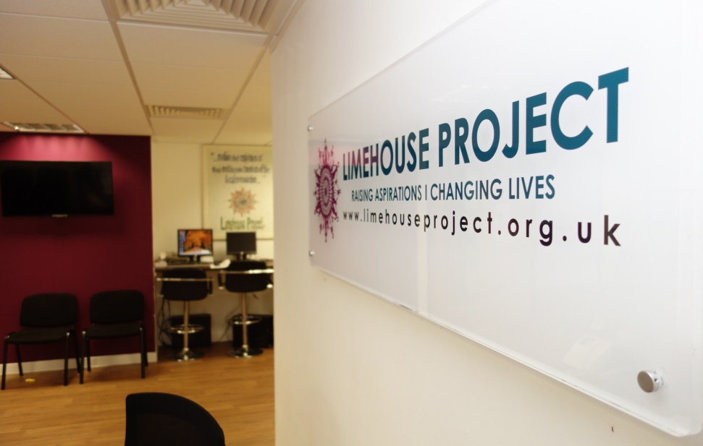

Recruitment Pack

Note from the Chair

Advert Job Description Person Specification







6th Aug 2020

Dear Applicant:

Re: Welfare Benefits Adviser

Thank you for taking the time to consider the role of the Welfare Benefits Adviser Position at the Limehouse Project.

The Limehouse Project (LHP) is a thriving grassroot and award-winning organisation with a history of servicing the Limehouse area of Tower Hamlets and East London since 1984. Our menu of services continue flourish thanks to investments and trust placed in us by clients, funders and partners. We provide free legal, welfare and family advice, accredited learning, capacity-building, employment support programmes, health and wellbeing activities for all age group. We work independently and in partnership with key third sector, business and statutory organisations to ensure each client’s are given timely and active support they need to positively move forward in life. 48 children are also in our care at our pre-school nursery opened in 2017.
We are now seeking a dynamic Welfare Benefits Adviser, with a genuine understanding of, and commitment to, the aims and values of the LHP, and provide high-quality advice and support to our clients to empower them towards financial independence.

Enclosed are as follows:

1. Job description & Person specification
2. Application Form
3. Guidance Notes on completing the Application Form
4. Limehouse Project Recruitment Monitoring Form
5. Annual Report to give you some background information about Limehouse Project

If you would like an informal chat about the role, contact Memuna Iyasere, Advice Service Coordinator on 0207 538 0075 or m.iyasere@limehouse project.org.uk

Thank you again for your interest in this role and we look forward to receiving your completed application.

Please send the completed application form along with a covering letter to Limehouse Project at recruitment@limehouseproject.org.uk

Closing date: 24TH of August
We look forward to receiving your completed application.

Yours sincerely,

Mrs. Farida Yesmin
C.E.O

Job Advert

Position: Welfare Benefits Adviser
Hours: 28 hours per week
Contract: 2 years Fixed Term Contract
Salary: £26,236 per annum incl. London Weighting

Role: Welfare Benefits Adviser

Limehouse Project has this excellent opportunity for a Welfare Benefits Advisor working 28 hours per week. As a Welfare Benefits Advisor, you will provide high-quality advice and support to our clients to empower them towards financial independence.

Day to day
Your key responsibilities as Welfare Benefits Advisor:

- Deal effectively with advice queries from clients at assigned work venues, remote working such as telephone and zoom, face to face, email where needed
- Undertake full welfare benefit assessments including progressing applications, revisions and appeals on behalf of the clients to maximise benefit entitlement
- Provide high quality generalist advice and casework in housing, welfare benefits, debt and other benefits related issues.
- Provide practical assistance in checking benefits entitlement; making new claims , conducting better – off calculations, form filing, advocating on service users behalf, writing a mandatory reconsiderations request and appeals, liaising with and referring to other specialist agencies where appropriate
Does this describe you?
You are clients focused with excellent communication skills, both verbal and written, showing the ability to meet the needs of a varied clients base. You will have at least one-year experience in the field of Welfare Rights. NVQ Advice Level 3 or equivalent is desirable but by no means essential.

What's in it for you?
In return for your hard work and dedication, we offer you:
- Competitive pay
- Good quality training and personal development support
- Eye tests
- 28 days holiday per year

Thank you again for your interest in this role and we look forward to receiving your completed application.

Please send the completed application form along with a covering letter to Farida Yesmin, Chief Executive Limehouse Project at recruitment@limehouseproject.org.uk

Closing date: 24th of August
Interview date: Friday the 4th of September

Job Description
Welfare Benefits Adviser

Accountable To: The CEO
Responsible To: Advice Services Coordinator
Hours: 28 hours per week
Main Location: Based: St Anne Street – Unit 2, 789-791 Commercial Road Centre and other outreach venues across the borough
Salary: £26,236

PURPOSE OF ROLE
- Deal effectively with advice queries from clients at assigned work venues, remote working such as telephone and zoom, face to face, email where needed
- Undertake full welfare benefit assessments including progressing applications, revisions and appeals on behalf of the clients to maximise benefit entitlement
- Provide high quality generalist advice and casework in housing, welfare benefits, debt and other benefits related issues.
- Provide practical assistance in checking benefits entitlement; making new claims , conducting better – off calculations, form filing, advocating on service users behalf, writing a mandatory reconsiderations request and appeals, liaising with and referring to other specialist agencies where appropriate
- To be responsible for the delivery of an agreed annual advice work-plan, meeting targets and milestones.

- To strictly adhere to all LP policies, in particular those on confidentiality, GDPR, equal opportunities, case recording, file management policy etc. Strictly follow the AQS Quality System e.g. clients filing system, monitoring system, referral system etc, and keeping them up to date.

- Support volunteers where necessary for support and assistance to carry out their roles and develop their own learning
- To observe all rules relating to Health and Safety.

MONITORING AND EVAUATION:

- Responsible for maintaining a computerised CRM database and filing system of clients records related to the project

- To monitor the progress of project outputs outcome targets, milestones against delivery plan and regularly feedback information to the project manager to ensure any issues address at early stage

- In liaison with the Manager prepare statistical and written monitoring reports for funders, Director and the Management Committee where necessary.

- Maintain project files in according to the LHP’s project directory list provided by the project manager

- Carry our user feedback survey according to the LHP policy and submit analytical date to the project manager

- Contribute to project evaluation and production of annual report

GENERAL RESPONSIBILITIES

- To support the Limehouse Project’s overall goals and vision.

- Carry out day-to-day general administrative duties that are vital to the smooth running of advice work such as responding to letters, doing follow up work etc, and its on-line appointment sheets for LP and external partners.

- Attend Limehouse Project staff meetings regularly.

- Provide regular reports to Limehouse Project Service Manager.

- Carry out such other duties, as the LP manager and management committee shall from time to time require.

- Keep up to date by undertaking such further study or training, as may be necessary or which may be required by LP and which contributes to the provision of an effective service.

- Operate within the LP’s policies and practices including Equal Opportunities, Health and Safety including Risk Assessment, Safeguarding and the Protection of Children, Young People and Vulnerable Adults, Data Protection and confidentiality, Complaints and others.

- Assist colleagues in their roles as appropriate.

- To undertake other tasks as directed.

- The duties laid down in the job description may change following a review and in consultation between the post-holder and line manager.
PERSON SPECIFICATION
CATOGORY | REQUIREMENTS | ESSENTIAL/  DESIRABLE
Education & Qualifications | Level 3 qualification in Advice and Guidance | D
Experience & Knowledge | Minimum 1 year experience in similar post  Experience of providing welfare benefit and generalist advice work  An understanding of financial literacy.  Recording outcomes and report writing.  Working within a diverse community.  Detail knowledge on AQS Quality Mark standard  Good knowledge of computer systems - Microsoft Office, Apps, Google Docs, CRM (e.g. AIM’s, Advice Pro, Key2CRM software etc.).  Tower Hamlets and local issues | E  E  E  E  E  D  D  D
Aptitude | Committed to delivering a high-quality advice service  Highly motivated and enthusiastic approach to work.  Commitment to developing social policy based on local action with an ability to think in these terms  Commitment to the benefits of volunteering | E  E  D  E
Skills and Abilities | Excellent oral and written communication skills in English  Ability to work unsupervised and managed own workload  Ability to provide advice and guidance in a culturally sensitive manner  Ability to work under pressure, both on your own and as part of a team  Ability to effectively share learning, contribute to and influence development of good practice  Excellent organisational skills, (including attention to detail), managing multiple work streams, tasks and working to tight deadlines  Planning project delivery and monitoring and evaluating own workload and that of teams  Ability to accurately collect data, analyse project achievements, and contribute on production of monitoring report  Able to speak Sylheti/Bengali | E  E  E  E  E  E  E  E  D
Circumstances | You will be required occasionally to attend meetings, conferences etc. outside of normal office hours and at weekends | D
Equal Opportunities | Demonstrate in your application and interview an understanding and ability to reflect equality issues in all areas of work and to promote its importance to all service users. | E

Training
Limehouse Project will provide all necessary training and will encourage and where possible support the upgrading of appropriate skills and qualifications.

Volunteers
Limehouse Project is committed to volunteers internal and external and is committed to supporting individual’s involvement in their community and their empowerment and develop through these routes. All team members will be expected to support the volunteering and development ethos and to work with/train volunteers to promote and facilitate the involvement of volunteers wherever appropriate.

Limehouse Project is an equal opportunities employer that values the importance of diversity and positively welcomes applications from all members of the community, including those with disabilities. Please note that successful applicants to this post will be subject to a DBS - Disclosure and Barring Service Check. Confirmation of appointment would be dependent on a satisfactory DSB check.

