
LIMEHOUSE PROJECT

RAISING ASPIRATIONS I CHANGING LIVES
St Anne Unit 2, 789-791 Commercial Road
London. E14 7HG
Tel: 020 7531 4881

The Limehouse Project
Deputy Director Recruitment Pack

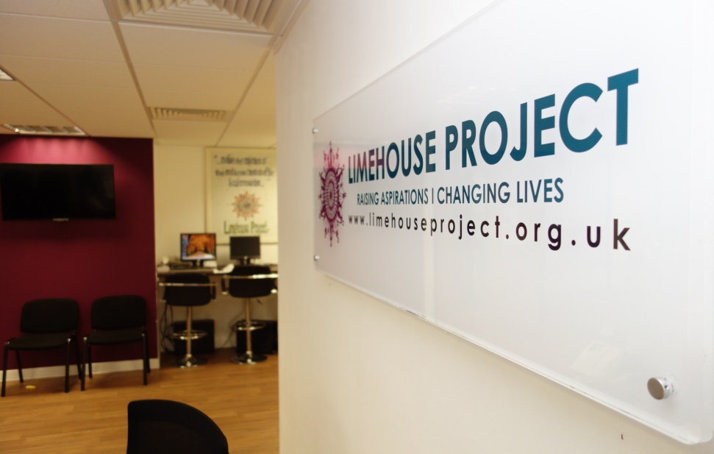

Recruitment Pack

Note from the Chair

Advert Job Description Person Specification





5th February 2018

Dear Applicant,

Re: Deputy Director Position

Thank you for taking the time to consider the role of the Deputy Director Position at the Limehouse Project.

The Limehouse Project (LHP) is one of Tower Hamlets leading community anchor organisations, providing a wide range of services to communities throughout east London. From legal advice on a range of social welfare issues to financial capability services, accredited learning programmes, and employment support services, we work both independently and in partnership with a wide range of other organisations and businesses to ensure every one of our client’s is given the timely aid and active support they need to deal with – and move on from – whatever issue they face.
Limehouse Project is a thriving organisation with a history of servicing the local community since 1984. Our wide spectrum of services covering everything from the tackling of major health issues to helping people into work, continues to survive and flourish thanks to the investment and trust placed in us not only by our funders and partners, but our clients too.
2017 has indeed been a most remarkable year for the Limehouse Project. Not solely for our eternal teams and advice workers, but the thousands of people who have walked in through our doors in need of help. With the opening of our first independently-run pre-school, we have been able to extend our much-needed services to not just the elders of a family, but to the youngest members too,
We are now seeking an inspirational Deputy Director to assist in leading exciting new developments at the LHP. We want someone who will have a genuine understanding of, and commitment to, the aims and values of the LHP and work effectively alongside the Director in the development and delivery of the LHP’s strategic plans and to further cement our reputation and our financial base.

I have pleasure in enclosing the following:

1. Job description & Person specification
2. Application Form
3. Guidance Notes on completing the Application Form
4. Limehouse Project Recruitment Monitoring Form
5. Annual Report to give you some back ground information about Limehouse Project

If you would like an informal chat about the role before applying, please do give Farida a call on 020 3069 7458.

Thank you again for your interest in this role and we look forward to receiving your completed application.

Please send the completed application form along with a covering letter to Farida Yesmin, Director, Limehouse Project at recruitment@limehouseproject.org.uk

Closing date: 9am, 12th March 2018.
Interview date: 19th to 22nd March

We look forward to receiving your completed application.

Yours sincerely,

Mrs. Farida Yesmin
DIRECTOR

JOB ADVERT
Deputy Director
Full time
Salary £45,000 per annum incl. London Weighting
We are seeking an inspirational Deputy Director to lead exciting new developments at the Limehouse Project in Tower Hamlets. You will be open, dynamic, engaging, and above all, passionate about establishing and safeguarding the very best services on behalf of the most vulnerable of east London’s communities.
The Limehouse Project (LHP) is one of Tower Hamlets leading community anchor organisations, providing a wide range of services to communities throughout east London. From legal advice on a range of social welfare issues to financial capability services, accredited learning programmes, and employment support services, we work both independently and in partnership with a wide range of other organisations and businesses to ensure every one of our client’s is given the timely aid and active support they need to deal with – and move on from – whatever issue they face.
We are now seeking an inspirational Deputy Director to assist in leading exciting new developments at the LHP. You will have a genuine understanding of, and commitment to, the aims and values of the LHP and work effectively alongside the Director in the development and delivery of the LHP’s strategic plans and policies.
You will have the ability to influence and generate high performance in others and the confidence and personal resilience needed to operate within a changeable environment – both economic and socio-political. You will be able to provide leadership and direction to staff in the absence of the Director, and be capable of taking the lead role in working to develop LHP’s new business/income-led initiatives (such as our new pre-school facility).
With a working history that merges organisational and financial management with experiences of working on behalf of a community, you will have extensive knowledge of how to work alongside a wide range of stakeholders. You will be able to communicate widely to different audiences – from local community groups to LHP’s extensive network of partners. You will be open, dynamic, engaging, and above all, passionate about establishing and safeguarding the very best services on behalf of the most vulnerable of East London’s communities.
This is a unique opportunity for an experienced, committed individual to work alongside inspirational and passionate colleagues at a very exciting stage of development at the LHP. We look forward to hearing from you.

Recruitment timetable:
Closing date for applications: 9am, 12th March 2018.
Interviews: 19th to 22nd March 2018
To download the job description and application form please visit the Limehouse Project website: www.limehouseproject.org.uk
Or email at recruitment@limehouseproject.org.uk
Please send the completed application form along with a covering letter to Farida Yesmin, Director, Limehouse Project or email it to recruitment@limehouseproject.org.uk

DEPUTY DIRECTOR
Job Description
SALARY: £45,000 per annum

LOCATION: Unit 2, 789-791 Commercial Road, London E14 7EY

POSITION OVERVIEW:
Reporting to the Executive Director (ED), the Deputy Director will have both internal and external facing responsibilities, ranging from client and project management (business development, framing of key approaches, high-quality client delivery, written products) to administration (information technology, reporting, facilities), and human capital (HR/recruiting, mentoring, career progression). The Deputy Director will partner closely with the ED to plan the Limehouse Project’s future growth and strategic response to an ever-increasing demand for the organisation’s services.

MAIN OBJECTIVES OF POST:
- To work closely with the Executive Director to implement and action the Limehouse Project’s Funding Strategy, Business Plan and Nursery Business Plan as agreed upon by the Management Committee;
- To direct, structure and lead teams to deliver outstanding client works as agreed by the Executive Director thereby supporting all the aims and objectives of the Limehouse Project; and
- To work under the direction of the Executive Director (ED) and deputise for him/her as and when required.

RESPONSIBLE TO:
Executive Director

HOURS OF WORK
Full-time (Monday to Friday, 9.00am – 5:00pm)

SALARY
£45,000 per annum incl. London Weighting.

MAIN DUTIES
GENERAL
To assist the Executive Director to:
- Promote and adhere to the aims and objectives of the Limehouse Project at all times;
- Build and maintain strong cross-borough, private, and public client relationships, representing the Limehouse Project in industry-group conferences, professional associations, and other public venues;
- Lead a team of professional workers to ensure the delivery of high standards of advice, education and training services to meet local and changing needs;
- Safeguard the future of the Limehouse Project’s programmes and works by launching, establishing and maintaining long-term income projects and funding revenues; and
- Develop thought leadership around specific topics/emerging practice areas and share in knowledge dissemination, reporting, and communications.
- Responsible for the overseeing the development and management of the Nursery Business

FUNDRAISING
- To act as a principal fundraiser for the organisation.
- To research, action and manage new fund-raising / income generating opportunities as outlined by the Limehouse Project’s Funding Strategy and Business Plan.
- To report on all actions regularly to the Executive Director and Management Committee.

FINANCIAL MANAGEMENT
- To assist in the planning, management, and control of all resources.
- To monitor and maintain day-to-day financial control e.g. cash flow / expenses
- To report on all actions regularly to the Executive Director and Management Committee.

STRATEGIC PLANNING
- To research, develop and take actions to meet the changing needs of clients.
- To work with both staff and the Management Committee to identify and develop those works as will meet both short-term and long-term needs of clients and the Limehouse Project.
- To produce and action strategic/financial plans for the benefit of the Limehouse Project.

POLICY DEVELOPMENT
In conjunction with the Management Committee:
- To regularly review existing policies to ensure they meet the requirements of funders, relevant parties and control procedures.
- To draft new policies when and as required / instructed.
- To assist in ensuring all Limehouse Project are followed by all staff and MC members

STAFF MANAGEMENT
To assist the Executive Director to:
- Line manage senior staff to ensure works are in accordance with job descriptions, informed by the aims and ethos of the Limehouse Project and comply with all policies at all times.
- To hold regular senior management and staff team / training / supervisory meetings.
- To implement disciplinary / grievance procedures in relation to senior staff where required.
- To carry out annual appraisals and monitor professional development of senior staff.

RECRUITMENT & INDUCTION
- To help monitor staffing resources.
- To assist in the recruitment and induction of senior staff.
- To assist and advise the Executive Director on the hiring of new staff members.

QUALITY OF SERVICE
- To actively remain aware of all relevant quality of service requirements and ensure senior staff are equally aware.
- To help monitor the quality of service being provided by senior staff and all projects being delivered by the Limehouse Project.
- To help ensure all relevant quality of service requirements are being met.

RECORDING & MONITORING
To help ensure, through consultation and discussion with senior staff, that:
- All necessary and appropriate records are maintained and are of a sufficiently high standard as to meet the requirements of the Limehouse Project, of any external monitoring agency and Quality of Service requirements.
- All necessary monitoring is properly carried out and in particular, that monitoring returns as required by funders are provided in a correct and timely manner.

REPORT WRITING
To assist the Executive Director in:
- Ensuring reports to funders and other external bodies are made in a timely and appropriate manner.
- Ensuring all reports are of a sufficiently high standard to meet the requirements of the project and of any external monitoring agency;
- Arranging the production of reports by senior staff to the Management Committee and any sub-committees as required.

COMMUNICATION
- To help ensure, both directly and through consultation with senior staff, that decisions and policies made by the Management Committee or any of its sub-committees or by the Director or by the senior management team, together with learnings and relevant information are communicated to all members of staff in a prompt and effective manner.
- To ensure confidentiality of information received.

PUBLICITY
- To help co-ordinate all publicity for the Limehouse Project.
- To ensure all publicity produced for the Limehouse project is accurate and appropriate.

WORKS WITH EXTERNAL AGENCIES
- To liaise with other agencies in the interests of the Limehouse Project.
- To establish appropriate consultative and co-operative networks with other agencies.
- To represent the Limehouse Project at appropriate meetings and forums.
- To report back to the Executive Director on the outcomes of such meetings and forums.

HEALTH & SAFETY
In conjunction with the Executive Director and Management Committee, work to ensure:
- All legal requirements pertaining to health and safety are met.
- All members of staff are aware of their own responsibilities in regards to health and safety.

I.T. DEVELOPMENT
To assist the Executive Director in
- Oversee the IT development of the Limehouse Project in line with strategic aims.
- To research, determine and action the IT needs of Limehouse Project.

PREMISES
To work with the Executive Director to:
- Ensure the premises of the Limehouse Project meet the needs of clients and staff.
- Investigate opportunities for securing new/additional premises as necessary for the development of the Limehouse Project.
- To action, realise and manage those premises resultant of the Limehouse Project’s Business Strategy and Business Plan.

DUTIES TO THE MANAGEMENT COMMITTEE
- To provide regular written reports to the Management Committee.
- To attend Management Committee meetings and sub-committee meetings as may be required and ensure all meetings are properly serviced.
- To undertake such training as may be necessary/required by the Management Committee.
- To carry out additional duties as the Management Committee may require.

DEPUTY DIRECTOR
Person Specification
Essential | Desirable
Skills, aptitude, knowledge and experience  - At list 3 years Experience in managing staff, motivating teams and recruiting new staff members.  - A track record of successful leadership of high performing organisations.  - Experience of leading and managing staff and volunteers.  - An understanding of staff induction, supervision, and appraisal processes.  - Previous experience of caring for, or working with vulnerable / ethnic minority communities in a voluntary or paid capacity.  - A commitment to the provision of high quality services with an interest in the development of services to meet the needs of minority communities.  - Knowledge of the barriers faced by ethnic minority communities and impacts of national and regional policy. | - Proven administrative experience, including handling of confidential staff and records and extensive budgets.  - Proven experience in actioning business strategies.  - Proven experience in fundraising.  - Proven experience of managing senior team leaders.  - Proven experience of working with external agencies and networks.
Personal qualities  - Passionate about working with and on behalf of vulnerable communities.  - Excellent organisational, record keeping and planning skills.  - Excellent written and verbal communication skills.  - A positive approach to inclusive practice with colleagues, team leaders and clients.  - Reliability and trustworthiness.  - Open mindedness and able to work alongside people from all backgrounds.  - A positive approach to gaining further / required qualifications. | - Leadership and management skills  - Flexibility – occasionally working hours might be changed.  - Able to work in teams of various sizes both internally and externally.
Qualifications  - Degree or equivalent qualification in Business Management | - Health & Safety certificate  - First Aid certificate  - Completion of other relevant courses

This post requires a DBS check as there may be periods of unsupervised access to children and vulnerable clients.

An Enhanced DBS and satisfactory references would be obtained prior to commencement of employment.

